Chess Game Requirements Spec5

Image5.png

Dolly

# Image0.png Chess Game

## Scenarios

| Scenario |
| --- |
| 1. Pass initialisation data to Image1.pngChess Game Model |
| 2. Initialise Chess Board Image1.pngChess Board Controller - displayChessBoard |
| 3. Initialise Welcome  Image1.pngWelcome Controller - displayWelcome |
| 4. Wait for Welcome Complete Image1.pngWelcome Controller |
| 5. playGame Image1.pngChess Board Controller |
| 6. Initialise End Game Image1.pngEnd Game Controller - displayEndGame |
| 7. Exit, close |

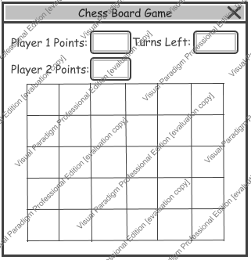

2. Initialise Chess Board Chess Board Controller - displayChessBoard

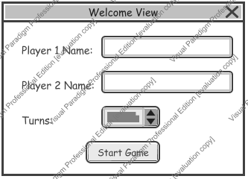

3. Initialise Welcome Welcome Controller - displayWelcome

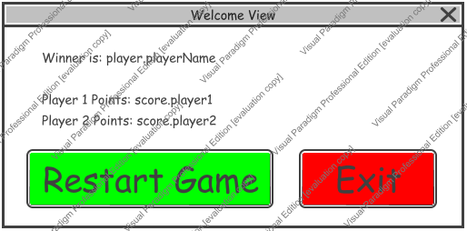

6. Initialise End Game End Game Controller - displayEndGame